integrated peripherals

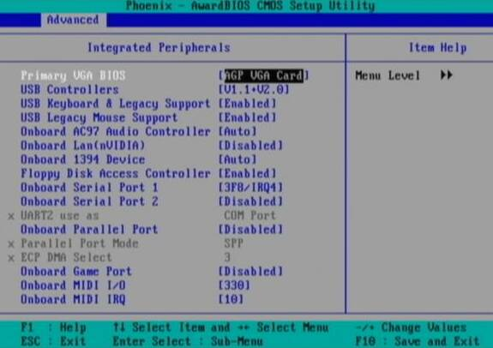

external peripherals such as keyboards